**JENKINS SETUP:**

**Prequisites:**

1. Download and install Jenkins.war
2. Post installation, install all the plugins required.
3. Setup username and password
4. Configure below in the global tool configuration in the Jenkins

* Java JDK path
* Maven path
* GIT path

1. Jenkins configured in localhost and a Job has been created.

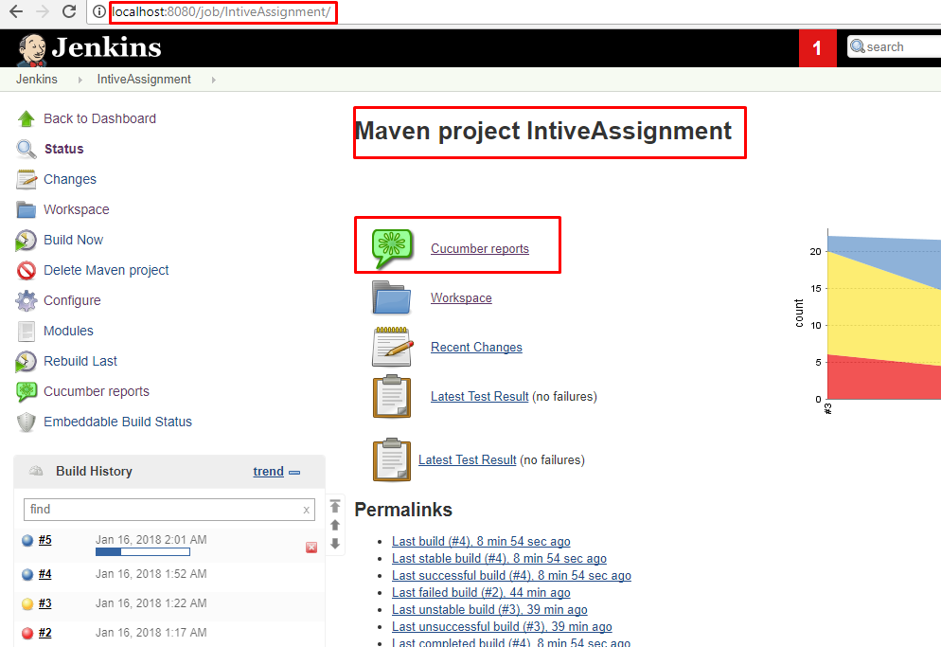

1. Configuration details of GIT in the source code management.

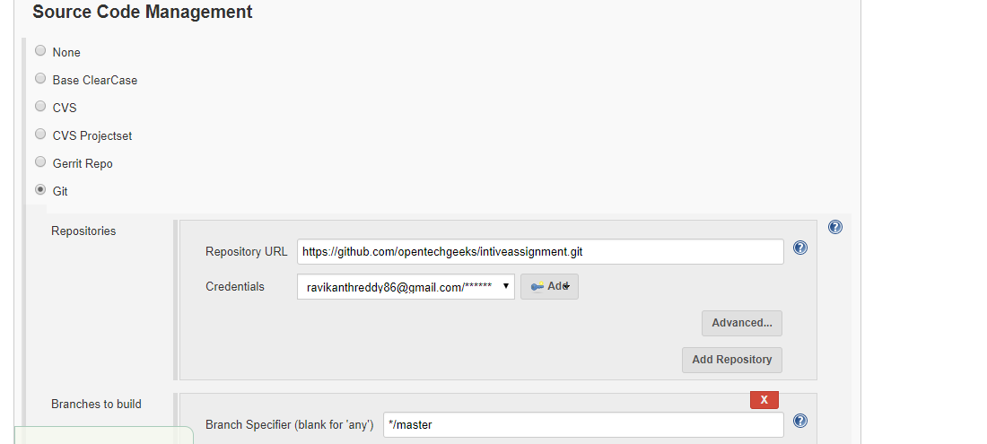

1. Configuration details for scheduling the build once a day in the noon

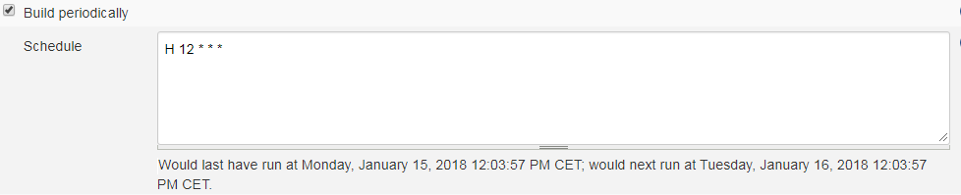

1. Build details with pom.xml and maven lifecycle phase to trigger the tests.

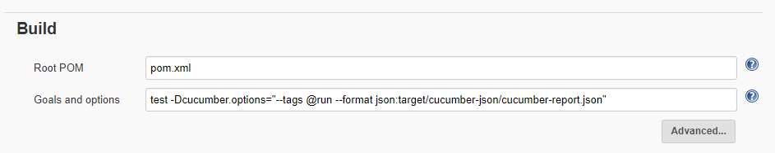

1. Post build actions to publish cucumber reports with the add in for cucumber installed.

